Hotel Reservation Form
(Hangzhou Blossom Tao Hotel)
* is required options

Please fill up the form and email to :  loc003@medinfo2017.org  Local Organizing Committee （LOC）  Ms. Cathy Zuo | Contact Person:* _____________________________________________  Organization:*_______________________________________________  Address:___________________________________________________  Country*_____________________ Postal Code: ___________________  Tel:*__________________________ Fax:________________________  Email:*_____________________________________________________

Hotel booking Details:
1) Guest Name:* 2) Guest Name:
3) Guest Name: 4) Guest Name:
Room type*: (circle accordingly)
Superior room with 1 King Size Bed / Superior room with 2 Single Size Beds
Number of room(s):* Check in date:* Check out date：*____________________
Payment type: bank transfer
Pls. Indicate Guest name/ Event name/ Hotel booked on transfer slip and email to us.
Name of the account: Shanghai Technology Convention & Exhibition Co., Ltd.
Name of the bank: Bank of Communications, Shanghai Branch Shixi Sub-branch
350 Jiangning Road, Shanghai 200041, China
Swift Code: COMMCNSHSHI
CNATS:301290050480
RMB Account: 310066085018000761488
Please fill up the above form and email to: loc003@medinfo2017.org

Hotel Information

Hangzhou Blossom Tao Hotel | ROOM | The price per night  （With breakfast） | Free Services
Hangzhou Blossom Tao Hotel | Superior room with 1 King Size Bed  Superior room with 2 Single Size Beds | RMB 400 | Free Internet

Notes:
1.Payment must be made on or before 21 July 2017 to LOC directly.
2. The organizer has negotiated the above discounted rates. Please book before 21 July 2017 to enjoy these rates. Price and availability is subjected to change after deadline.
3.Cancellation of booking must be made before 7 July 2017 and inform the LOC, otherwise a one-night room charge will be applied.
4.If before 7 July 2017 was not canceled and not checked in, in case of failure to show up, a one-night room fee will be charged as penalty.

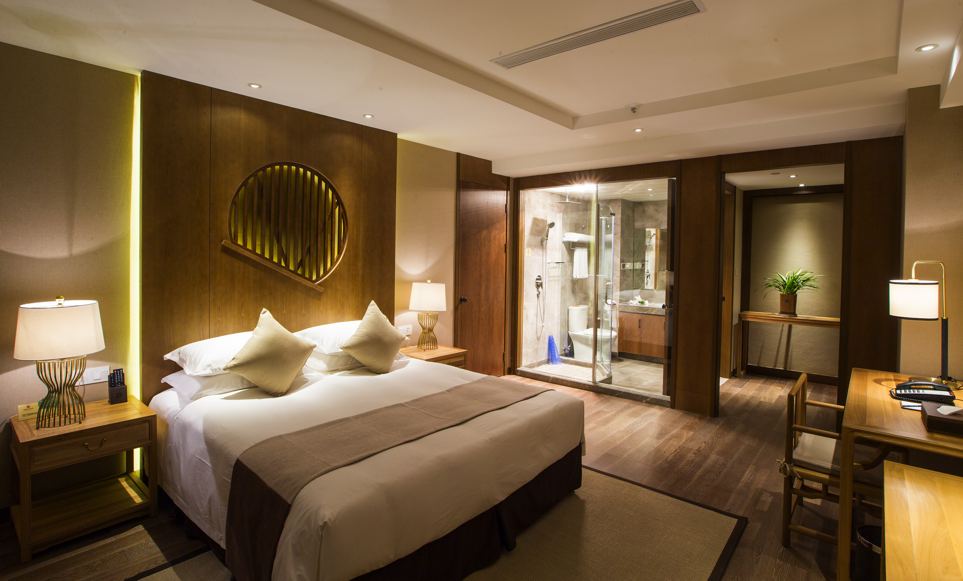  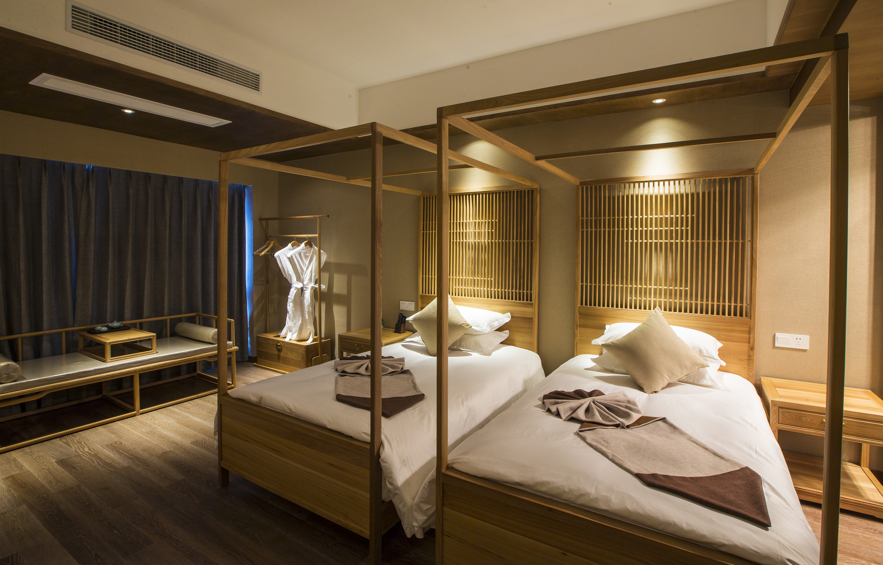 | Hangzhou Blossom Tao Hotel  Hangzhou Blossom Tao Hotel, located in the core area of Qianjiang Century City next to Olympic Sports Center, boasting the excellent geographical location. The hotel has the peculiar natural scenery in the surrounding areas; the beautiful Qiangtan River bank extends along at the foot of the hotel, so where we can a panoramic view the beautiful scenery of Qiangtan River  Only 10 km, 25-minute bus or taxi ride from the hotel to West Lake.  The hotel has 220 guestrooms (suites) of all types, mainly with the feature of the Chinese style, simple and elegant in design, flexibly elusive and graceful. The hotel provides the food and drinks in the characteristic restaurants, say, the Chinese and western style restaurant, Chinese characteristic cafeteria and special snack stands.  Travel information  located in the core area of Qianjiang Century City, 10 minutes to the exhibition hall on foot  15 km to Hangzhou Xiaoshan Airport  9 km to Hangzhou Railway Station  Address: No.800 Minhe Road，Xiaoshan District, Hangzhou, Zhejiang Province,China

